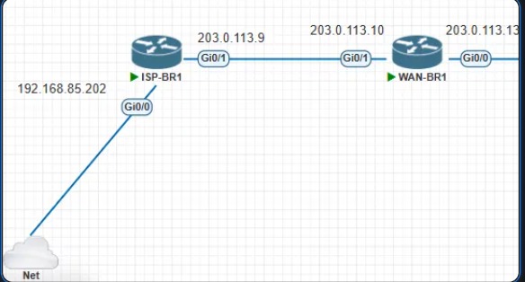
why doesn't it pinging 8.8.8.8
pinging: 192.168.85.132, 192.168.85.2(gateway to pc).
====================
Your ISP-BR1 can reach the local 192.168.85.x network (the Net cloud/NAT side), but 8.8.8.8 fails. Since .85.2 and .85.132 respond, Gi0/0 is up and the link to the cloud works. The problem is almost certainly routing or NAT on the path to the internet. Check these in order:
1. Default route on ISP-BR1
show ip route
You need a line like S* 0.0.0.0/0 [1/0] via 192.168.85.2. If there’s no default route, the router has no idea where to send 8.8.8.8 and the ping just times out. Fix:
ip route 0.0.0.0 0.0.0.0 192.168.85.2
(Use whatever the gateway of your Net/NAT cloud actually is. In GNS3/VMware NAT setups it’s usually .2, which matches your successful ping.)
2. Source address of the ping
When you ping from the router, the source IP is the exit interface’s address (192.168.85.202), which is fine for a NAT cloud. But if you have an ACL or NAT config on Gi0/0, make sure it isn’t blocking this.

3. Gateway/NAT on the host side
If the Net cloud is bridged to a VMware NAT adapter (VMnet8), the host must have internet and the VMware NAT service must be running. Test from your PC: ping 8.8.8.8. If the host can’t, the router won’t either. Also try ping 192.168.85.2 working vs. ping 8.8.8.8 failing, which strongly suggests the default route is missing, since .2 is on-link and doesn’t need one.

The culprit is the extra default route on ISP-BR1:
S* 0.0.0.0/0 [1/0] via 192.168.85.2
[1/0] via 192.168.85.1
HQ only has the single route via .2, which is why it works.
Fix: remove the .1 route on ISP-BR1
conf t
no ip route 0.0.0.0 0.0.0.0 192.168.85.1
end
show ip route
ping 8.8.8.8
You should now see only S* 0.0.0.0/0 [1/0] via 192.168.85.2.

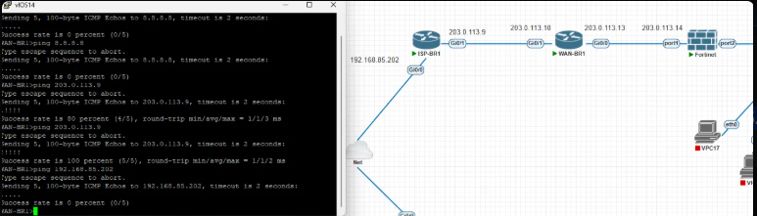
now we have WAN-BR1
why it can't ping 192.168.85.202
and can ping 203.0.113.9

Fix on WAN-BR1:
conf t
ip route 0.0.0.0 0.0.0.0 203.0.113.9
end
show ip route
ping 192.168.85.202

FW can’t ping anything.

Fix on the FortiGate:
config router static
edit 1
set dst 0.0.0.0 0.0.0.0
set gateway 203.0.113.13
set device port1
next
end
get router info routing-table all
execute ping 203.0.113.9

1. Enable admin access on the FortiGate (CLI)
config system interface
edit port1
set allowaccess ping https http ssh
next
end
UR PC
route add 203.0.113.0 mask 255.255.255.0 192.168.85.202

